Metro Ticket Generating System in ServiceNow
Phase 2: Backend Development & Configurations
Item | Details
Project | Metro Ticket Generating System in ServiceNow
Phase | Phase 2: Backend Development & Configurations
Platform | ServiceNow
Prepared by | Bharath Chowdary Tammineedi
Status | In Progress

1. Phase Overview
This phase develops the core logic, configures system settings, and sets up the backend integrations and automations of the Metro Ticket Generating System. It begins with the data architecture, which holds the station data used by the ticket booking process.

2. Data Architecture
Data architecture is the blueprint for how data is collected, stored, managed, integrated, and used across an organization. It defines the policies, standards, models, and rules that govern how data flows and supports business objectives. For this project, the data architecture starts with a custom table that stores the metro stations.

2.1 Activity 1: Creation of Table
- Navigate to System Definition > Tables.
- Click New to create a new table.
- Fill in the Table Information as shown below.
- Click Submit to create the table.
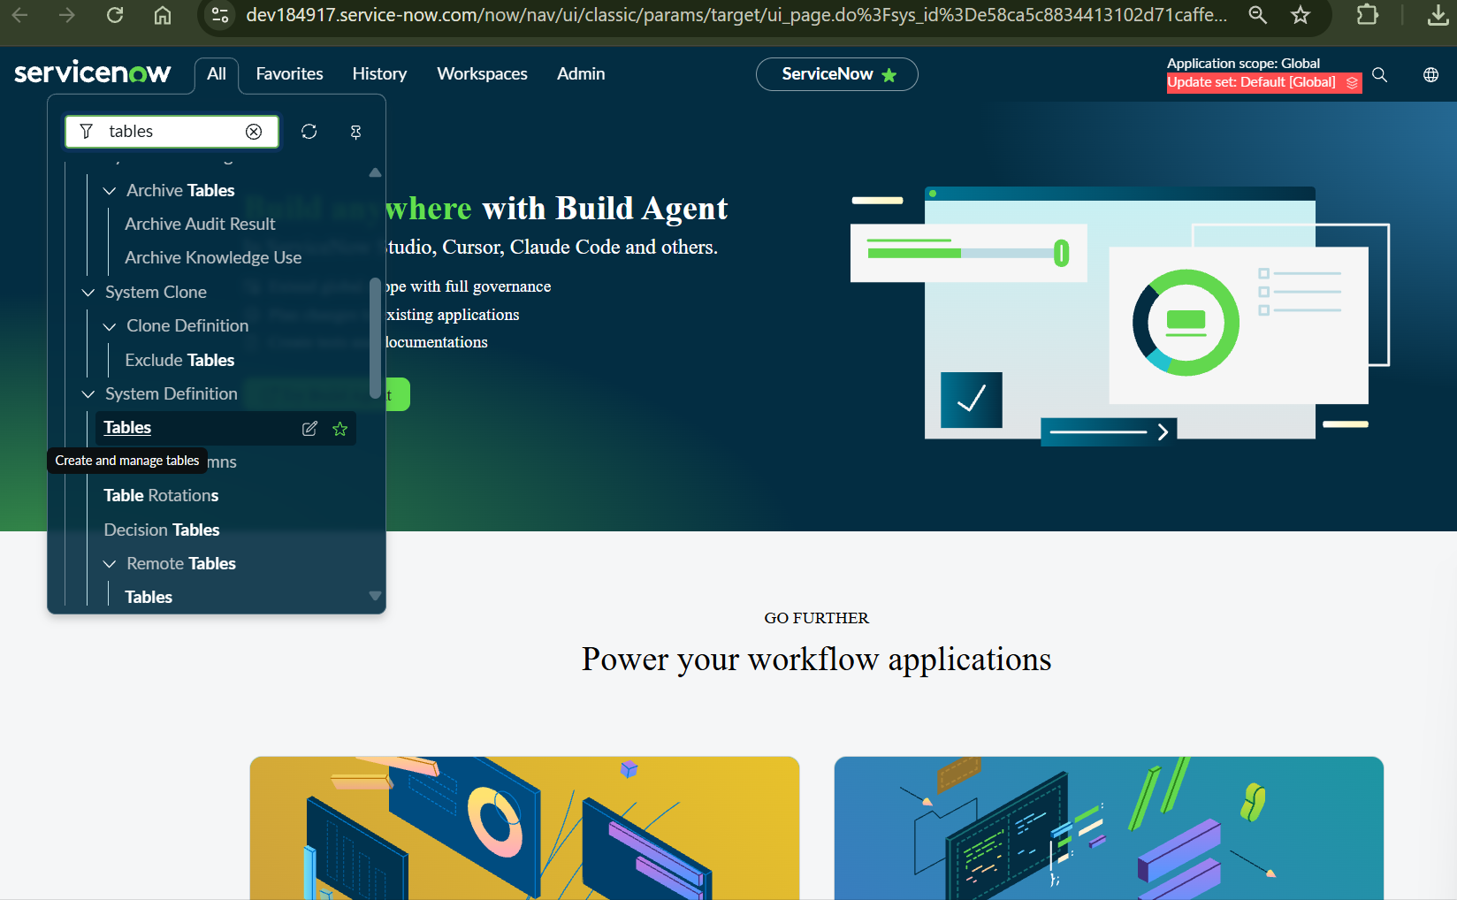
Figure 1: Opening System Definition > Tables from the Application Navigator
Property | Value
Label | Metro Station's Details
Name | u_metro_station_s_details

2.2 Activity 2: Creation of Fields
In ServiceNow, fields are created at the table level, so the table that will hold the field must be identified first.
- In the Application Navigator, type Tables in the search bar.
- Under System Definition, click Tables to see the list of all tables in the system.
- Search for and select the Metro Station's Details table.
- Open the table to see the list of its fields (columns).
- In the Columns tab, click Insert a new row to create a new field.
- Create the field described below. Fields can also be created with Form Builder, Form Design, or Form Layout.

Column Label | Column Name | Type
Station Name | u_station_name | String
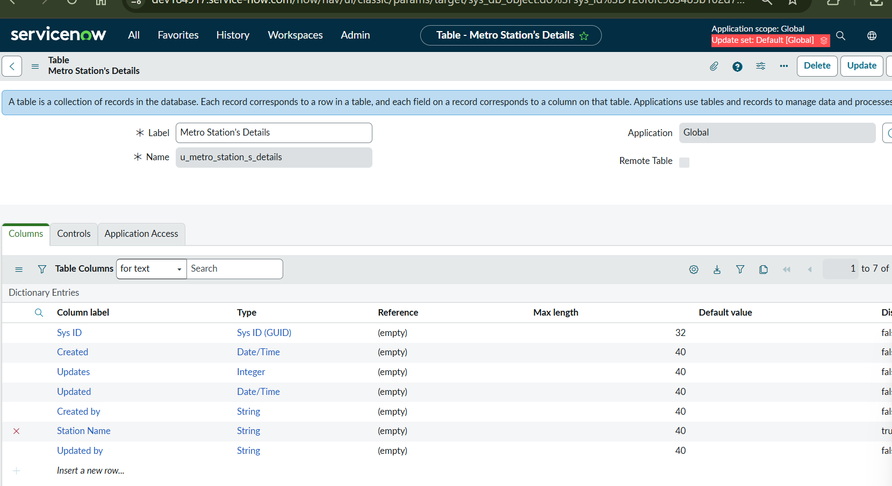
Figure 2: Metro Station's Details table with the Station Name column

2.3 Creating Station Records
After the field is created, open the table in List view using the Show List option and create the station records. The following stations were added:
No. | Station Name
1 | KOMMADI
2 | tanuku
3 | hyderabad
4 | vizag
5 | mvp colony
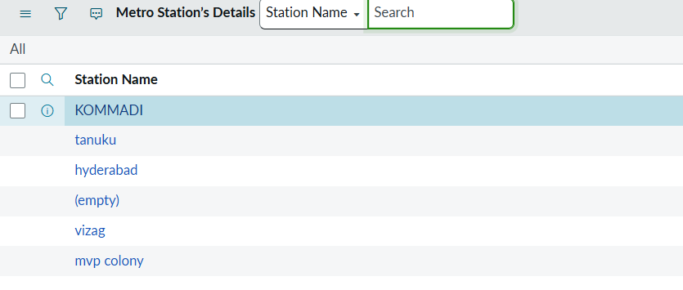
Figure 3: Station records in the Metro Station's Details list view

3. Automation Logic

3.1 Catalog Client Script for Fare Calculation
A Catalog Client Script was created to auto-populate the fare values. It supports dynamic automation: when the number of passengers changes, the fare is calculated from the selected stations and the type of journey.
Activity 1: Navigation to Catalog Client Script
- Navigate to Service Catalog.
- Click Maintain Items.
- Search for the Book A Metro Ticket item.
- Open the item and go to the Related Lists.
- In the Related Lists, select Catalog Client Script.
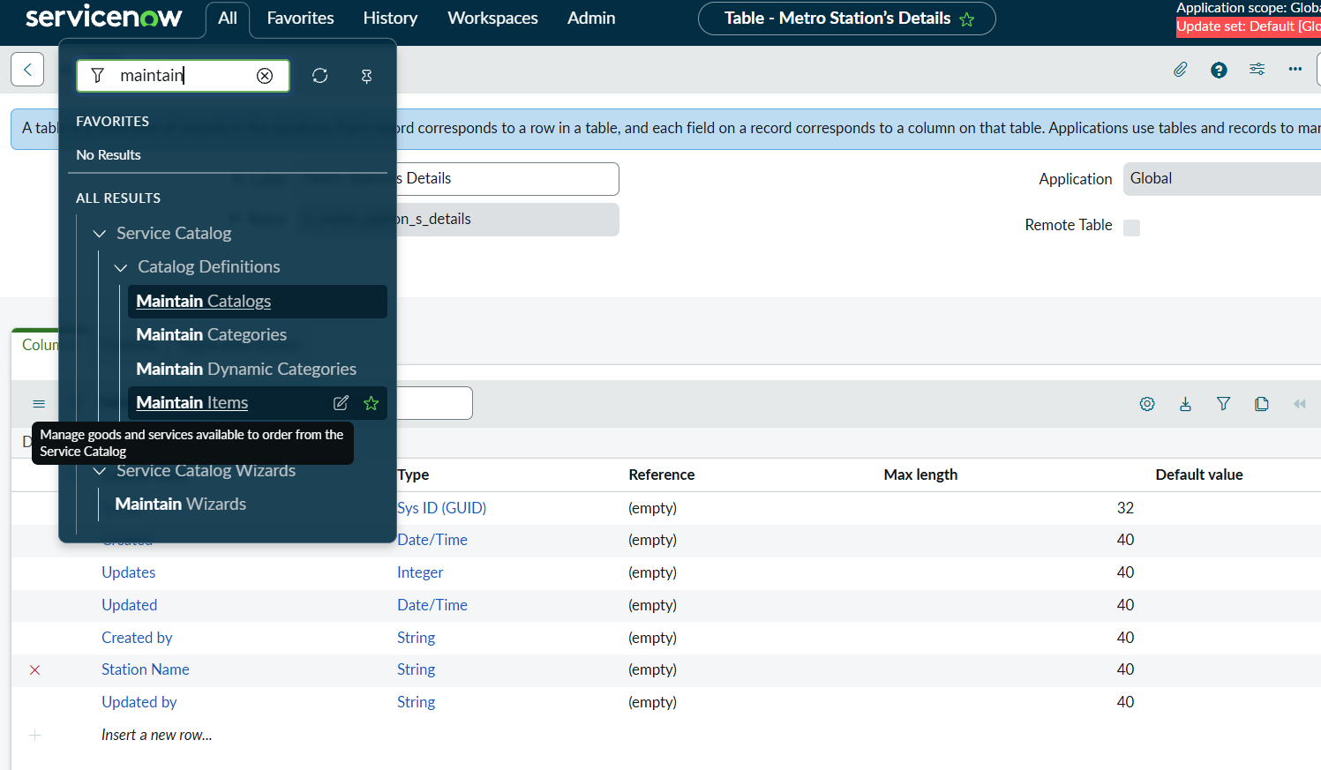
Figure 4: Opening Service Catalog > Maintain Items from the Application Navigator
Activity 2: Configuring the Catalog Client Script
- In the Catalog Client Script related list, click New.
- Fill in the Name and select UI Type: All.
- Select the Type of script: onChange.
- Select the variable name: No of Passengers.
- Write the script as per the fare logic.
- Save the client script.
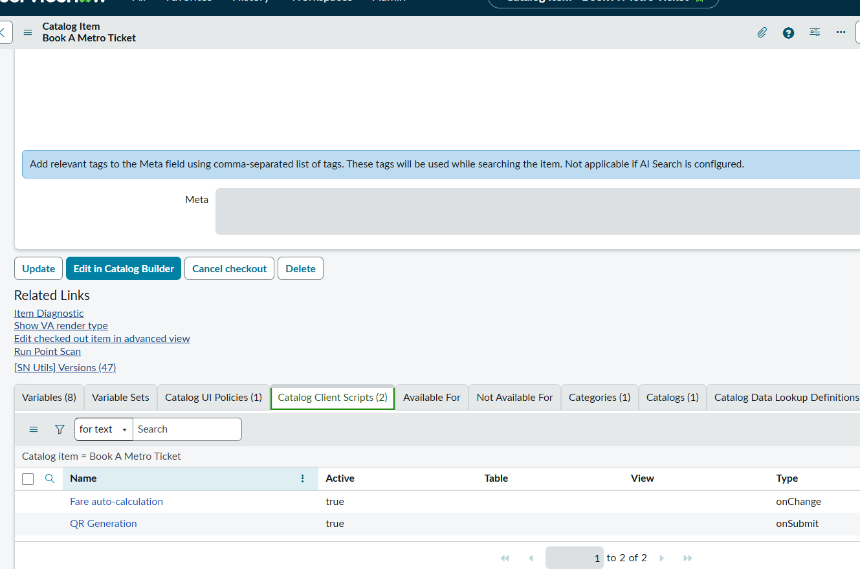
Figure 5: Catalog Client Scripts on the Book A Metro Ticket item: Fare auto-calculation (onChange) and QR Generation (onSubmit)

The fare logic uses the following rates per passenger. The source station is Ameerpet for all routes:
Route | Single Journey (Rs) | Return Journey (Rs)
Ameerpet to Madhapur | 30 | 60
Ameerpet to LB Nagar | 50 | 100
Ameerpet to Kukatpally | 30 | 60
Ameerpet to Jubilee Hills | 20 | 40

If the selected route does not match any of these, both amount fields are cleared.

Client Script: Auto-populate Fare Values between Stations
function onChange(control, oldValue, newValue, isLoading) {
if (isLoading || newValue == '') {
return;
}

// Get Source and Destination
var source = g_form.getValue('starting_from');
var destination = g_form.getValue('going_to');

// Passenger Count
var numPassengers = Number(newValue);

// Get Journey Type (1 = Single, 2 = Return)
var journeyType = g_form.getValue('type_of_journey');

// Ameerpet -> Madhapur
if (source == 'a7cc5f4683b60b143f98f065eeaad356' &&
destination == 'f4ec9f4683b60b143f98f065eeaad37a') {
if (journeyType == '1') {
// Rs 30 per passenger
g_form.setValue('amount_for_single_journey', numPassengers * 30);
g_form.clearValue('amount_including_return');
} else if (journeyType == '2') {
// Rs 60 per passenger
g_form.clearValue('amount_for_single_journey');
g_form.setValue('amount_including_return', numPassengers * 60);
}
}
// Ameerpet -> LB Nagar
else if (source == 'a7cc5f4683b60b143f98f065eeaad356' &&
destination == 'f556f41e83724b143f98f065eeaad3e3') {
if (journeyType == '1') {
// Rs 50 per passenger
g_form.setValue('amount_for_single_journey', numPassengers * 50);
g_form.clearValue('amount_including_return');
} else if (journeyType == '2') {
// Rs 100 per passenger
g_form.clearValue('amount_for_single_journey');
g_form.setValue('amount_including_return', numPassengers * 100);
}
}
// Ameerpet -> Kukatpally
else if (source == 'a7cc5f4683b60b143f98f065eeaad356' &&
destination == '0246305683b24b143f98f065eeaad34e') {
if (journeyType == '1') {
// Rs 30 per passenger
g_form.setValue('amount_for_single_journey', numPassengers * 30);
g_form.clearValue('amount_including_return');
} else if (journeyType == '2') {
// Rs 60 per passenger
g_form.clearValue('amount_for_single_journey');
g_form.setValue('amount_including_return', numPassengers * 60);
}
}
// Ameerpet -> Jubilee Hills
else if (source == 'a7cc5f4683b60b143f98f065eeaad356' &&
destination == '1136fc1683b24b143f98f065eeaad33f') {
if (journeyType == '1') {
// Rs 20 per passenger
g_form.setValue('amount_for_single_journey', numPassengers * 20);
g_form.clearValue('amount_including_return');
} else if (journeyType == '2') {
// Rs 40 per passenger
g_form.clearValue('amount_for_single_journey');
g_form.setValue('amount_including_return', numPassengers * 40);
}
}
else {
// Clear amounts if no route matches
g_form.clearValue('amount_for_single_journey');
g_form.clearValue('amount_including_return');
}
}

3.2 Catalog UI Policy Configuration
A Catalog UI Policy displays additional fields when certain choices are made. Conditional logic and field dependencies are configured within ServiceNow.
Scenario: If the user selects Mode of Payment as Others, the Enter payment mode field should be displayed.
- Navigate to Catalog Items.
- Open the Book A Metro Ticket item.
- In the related lists, open Catalog UI Policy.
- Click New to configure a new UI policy.
- Select Applies to: Catalog item.
- Select the catalog item: Book A Metro Ticket.
- Provide a short description, if required.
- Apply the condition: Mode of Payment is Others.
- Click Save. After saving, the UI Policy Actions related list appears.
- Click New to configure a new UI Policy Action and select the variable to display on the condition.
- Set Visible to True.
- Update the UI policy and test it on the catalog form.
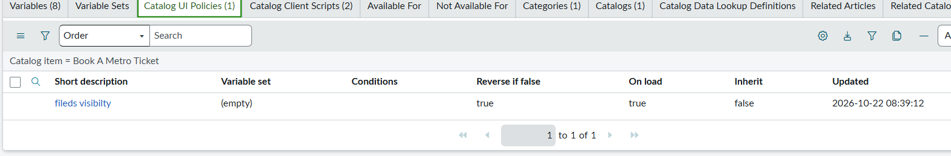
Figure 6: Catalog UI Policy configured on the Book A Metro Ticket item

3.3 Catalog Client Script for QR Code Generation
A Catalog Client Script was used to generate the QR code when the user submits the form.
- Navigate to Catalog Items.
- Open the Book A Metro Ticket item.
- In the related lists, open Catalog Client Script.
- Click New to configure a new client script.
- Select Applies to: Catalog item.
- Select the catalog item: Book A Metro Ticket.
- Provide a short description, if required.
- Select the type of client script: onSubmit.
- Write the code as per the requirement.
- Click Save.

The QR Generation script appears with the onSubmit type in Figure 5. How it works: on the first Checkout click the script builds a QR code image URL and shows it in a modal using the metro_qr_widget widget, and the submit is held back. After the QR ticket is shown, the user clicks Checkout once more to confirm and submit.

Client Script: Generate QR Code
var metroQrDone = false;

function onSubmit() {
// Second Checkout click: QR already shown, allow the submit
if (metroQrDone) {
return true;
}

var sysId = g_form.getUniqueValue();
var dummyURL = 'https://example.com/ticket?id=' + sysId;
var qrImageUrl = 'https://api.qrserver.com/v1/create-qr-code/?size=250x250&data=' + encodeURIComponent(dummyURL);

spModal.open({
title: "Your Metro QR Ticket - click Checkout once more to confirm",
widget: "metro_qr_widget",
widgetInput: { qr_url: qrImageUrl }
}).then(function() {
metroQrDone = true;
});

return false; // block only the first Checkout click
}

4. Summary
The Metro Station's Details table (u_metro_station_s_details) and its Station Name field (u_station_name) were created, and the station records were added. The automation logic was then configured on the Book A Metro Ticket catalog item: a Catalog Client Script that auto-populates the fare, a Catalog UI Policy that shows the Enter payment mode field when Mode of Payment is Others, and a Catalog Client Script that generates the QR code on submit.

